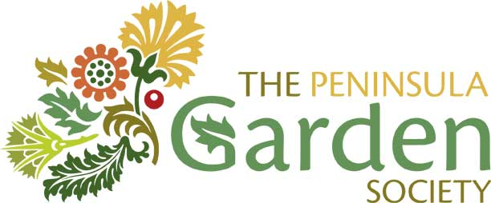

A MORE DETAILED HISTORY

BY OUR PRESIDENT, JIMMY SCOBIE

In 1993, some keen and knowledgeable gardeners in West Penwith decided to form a group to meet to share information and increase their knowledge of gardening and horticulture using Lamorna Village Hall as their meeting place.

Although West Penwith is often subject to damaging gales in winter it is very suited to successfully growing outdoors both native and exotic species of plants collected by the many famous British plant collectors, garden creators and nursery men especially where shelter from the elements can be enjoyed or provided.

The first formal meeting of the Peninsula Garden Society was held on the 20th October 1993 when the following officers were voted on to the first committee –

Chairman – Brian Dodd
Secretary – Peter Maddern
Treasurer – Maryella Pigott

Among the other members of the committee of the new Society in 1993 were Avril Taylor, who is still an active member, Jenifer Hilliard, Peter Blacker, Brian Blowers and Kate Pearson.

The guest speaker at the first formal meeting was Philip McMillan-Browse who has been director of the Saratoga Horticultural Foundation in California, director of the RHS garden at Wisley and horticultural director at the Lost Garden of Heligan.

Over the years, the following memorable activities have been greatly enjoyed by the Society’s members:

Speakers at Regular Monthly Meetings
Philip McMillan-Browse was followed by a succession of excellent entertaining speakers generally bringing beautiful slides.

An incomplete list of some of their names will remind members who attended of how good they were. Speakers included Sally Corbet, Peter Clough, Jane Bird, Rob Senior, Charlie Pridam, Dr Neil Armstrong, Gerald Hayman, Tim Smit, Alistair Rivers, Bill Johnson, J Froggart, Bill George, Mike Nelhams, Major JA Hibbert, Stephen Mule, Barry Champion. Tracy Wilson, Lady Skelmersdale, Mike Bell, Sir Ferrars Vyvian, Ian Wright, James Tresider, Peter Horder, Michael Snellgrove, Chris Osborne, Charles Fox, Amanda Richardson, and many others.

To these can be added the head gardeners or owners of many of Cornwall’s famous great gardens and plant collections who often told us about their plant hunting expeditions.

Memorable Visits
Both as a group and self-drive, to most of Cornwall’s great gardens, and some in Devon and of course to the memorable gardens of our own fellow members of the Peninsula Garden Society – always beautifully presented.

Those who were there will never forget a memorable visit by coach to RHS Rosemoor that broke down twice when travelling on the A30 near Lifton when full of our members!!

Memorable Social Events
There have also been many memorable parties, lunches, teas and BBQs especially those at members’ gardens, the village hall at Lamorna and at Trengwainton and Trewidden.

We also have regular plant and book sales, raffles and flower and plant competitions.

Posters
For many years the Society advertised future meetings with very good quality posters produced by Mr Tom Willgoss of Pocklington, York, whose daughter was a member of the society.

Local Horticultural Shows
The Society, and many of its members, have given good support to and/or obtained good competition results at the Penzance Spring Flower Show (when held at St John’s Hall and now held at Marazion), St Buryan Horticultural Society and Cornwall Garden Society.

Finally, the secret of the success of the Society is the friendly and light touch that the members bring to its activities.

